Dataset Creation with GSAM2

# Recommended Pipeline

For each of the recommended steps, instructions to run the corresponding script are given in the rest of the document.

1. Create yolo dataset with SAM 2
2. Clean dataset with SAM 2
3. Clean noise in dataset
4. Fine-tune Yolo with the clean dataset
5. Extract shape features to train shapes classifier
6. Train shapes classifier
7. Inference with YoloV8 + SAM2 + Random Forest

# Yolo Dataset Creation with SAM 2

## Setup

# Install SAM2

git clone https://github.com/facebookresearch/sam2.git && cd sam2

pip install -e .

# Download checkpoints

cd checkpoints && \

./download_ckpts.sh && \

cd ..

## Run Script

Open script *create_dataset_with_sam2.py* and make sure to setup the input and output folders correctly as well as the SAM 2 checkpoint and cfg files.

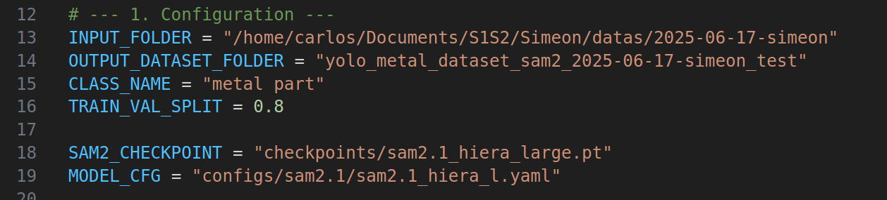

Run script: *python* *create_dataset_with_sam2.py*

# Cleaning Yolo Dataset with SAM 2

Open script *clean_dataset.py* and set dataset folder, checkpoint, and CFG paths correctly

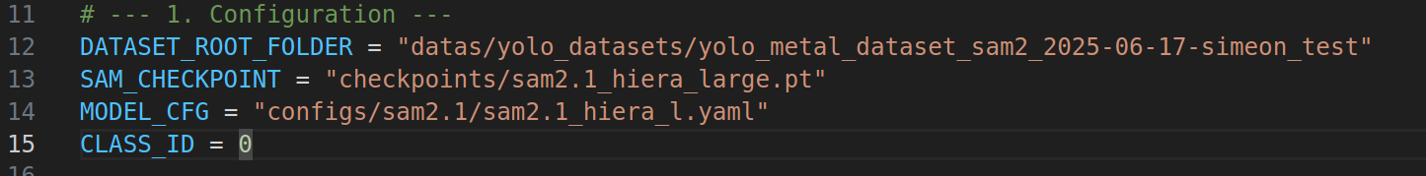

Run script: *python clean_dataset.py* then select *train* or *val* set to clean



Right click on a mask to delete it, for example right click on the background as seen below

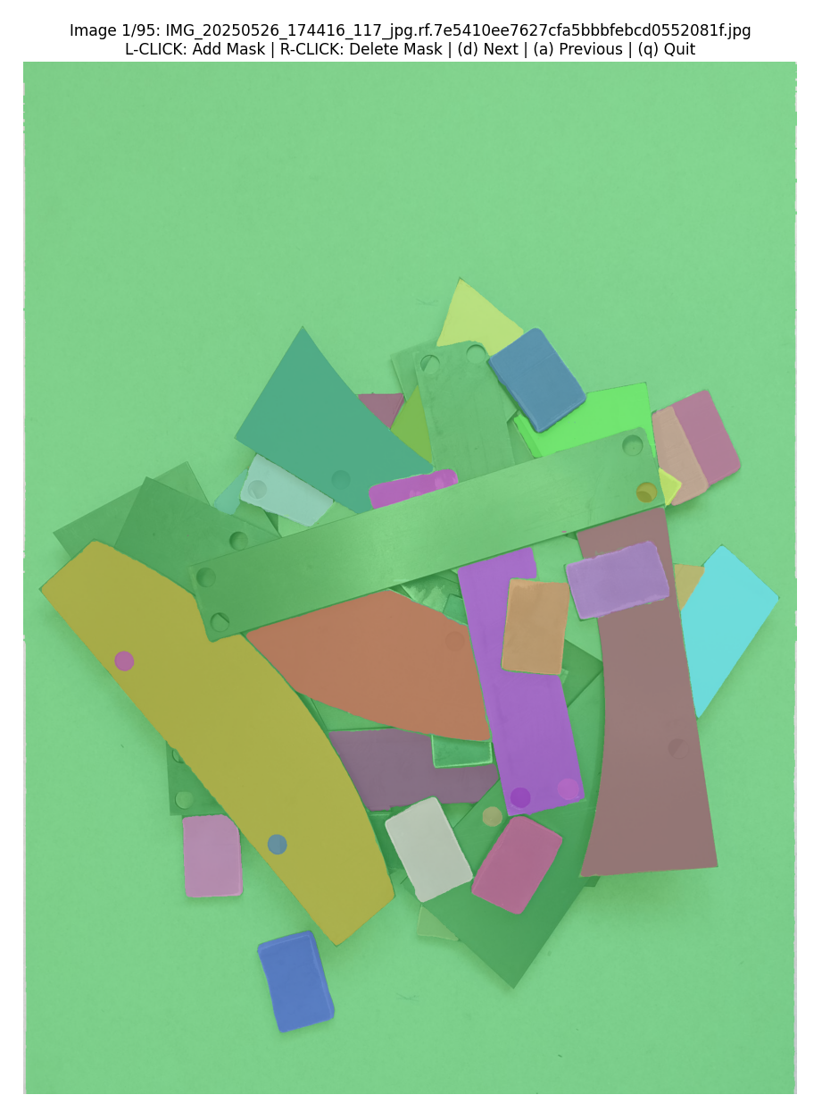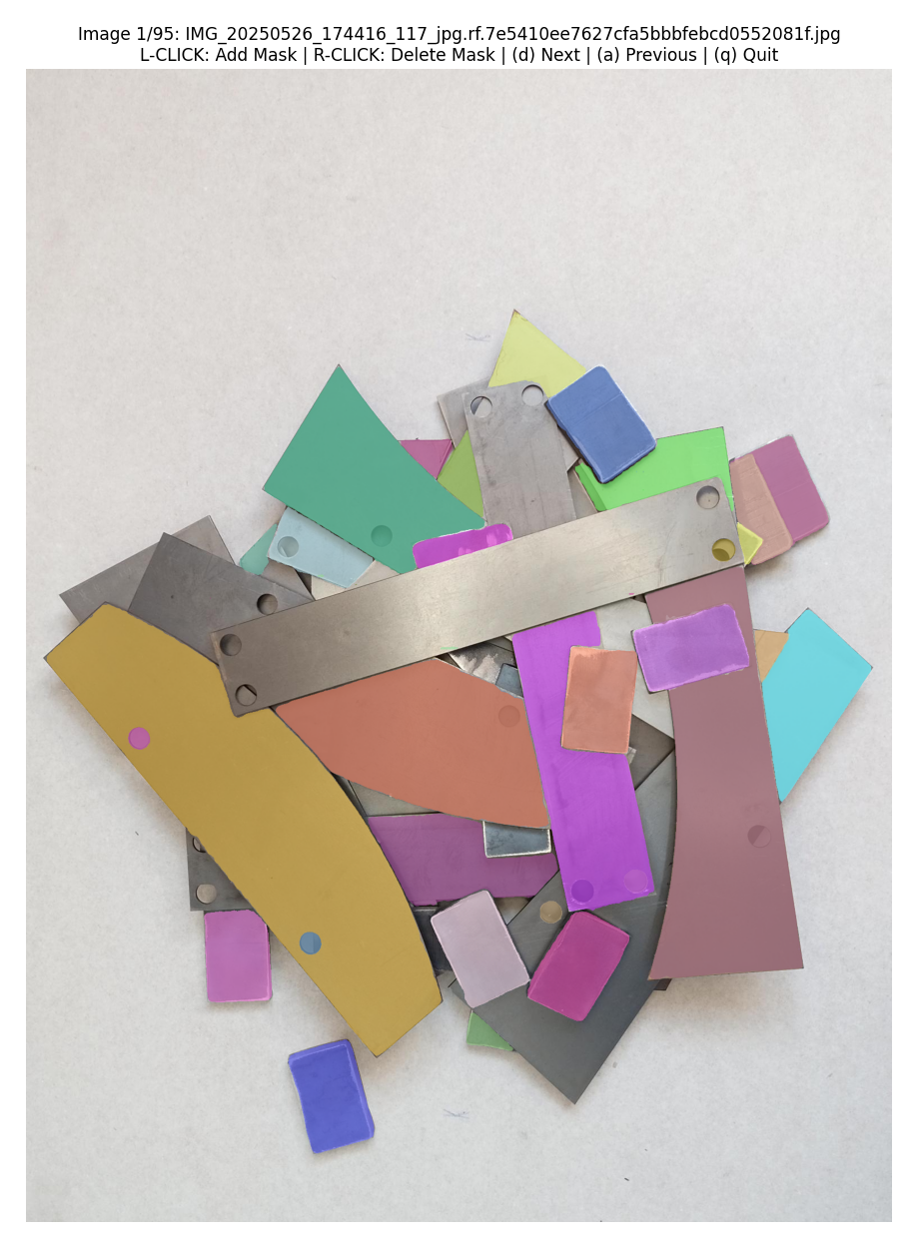

Left click on a mask to add it (will turn green until you confirm), press *y* to confirm or *n* to cancel

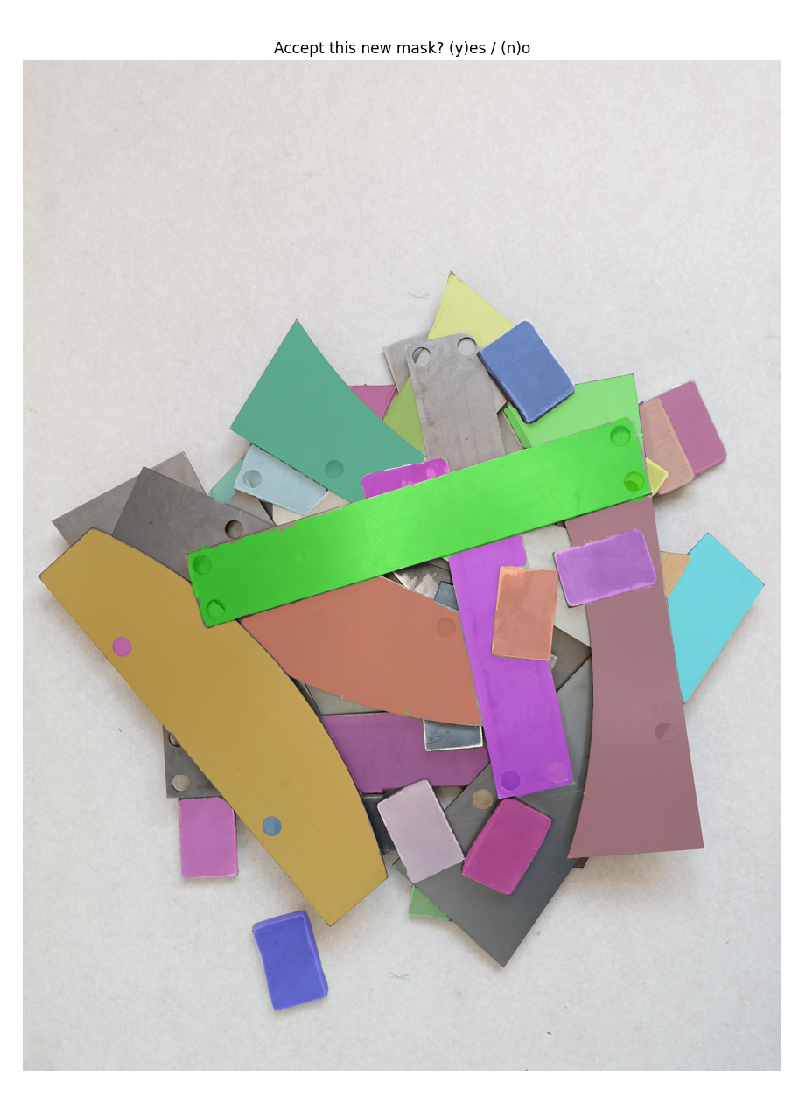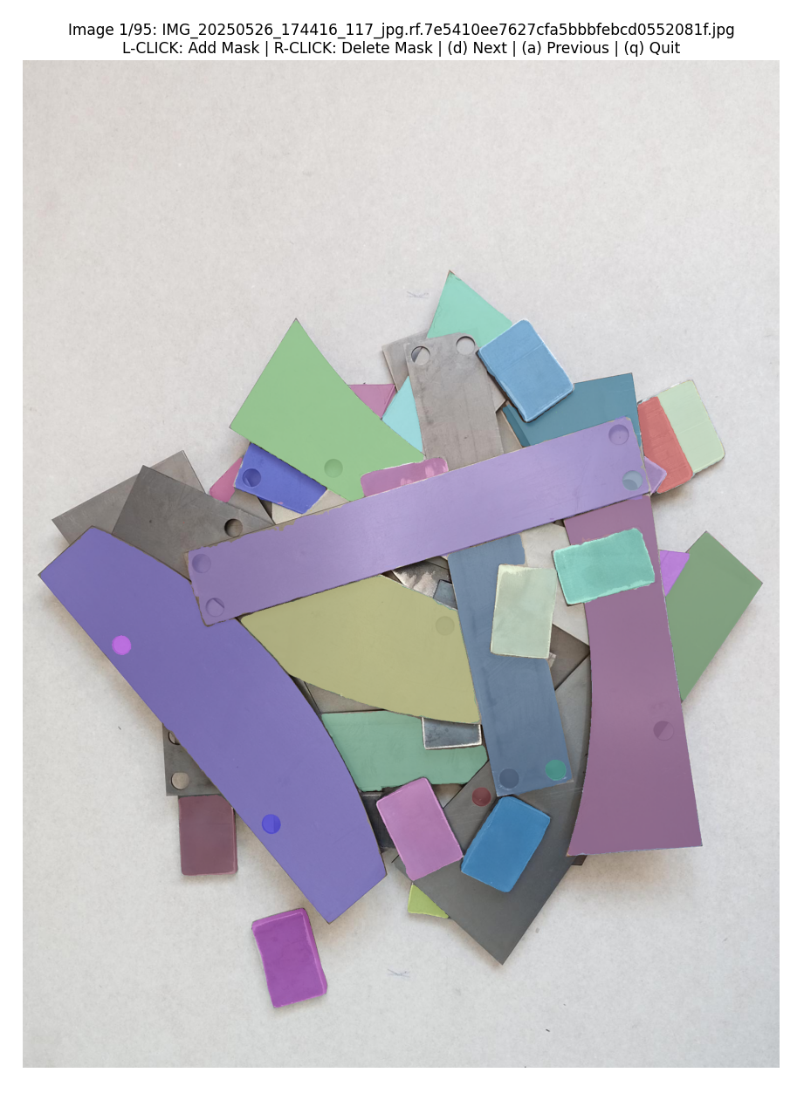

Move to the next image (*d*) or previous image (*a*) and continue the process. Press *q* to quit. Do the same for both the *train* and *val* set until the entire dataset is clean.

# Clean Noise in Dataset

This script will remove all of the round masks for the holes in the parts as well as very small masks resulting from noise and disconnected components

Open the script *clean_noise_dataset.py* and set the dataset path

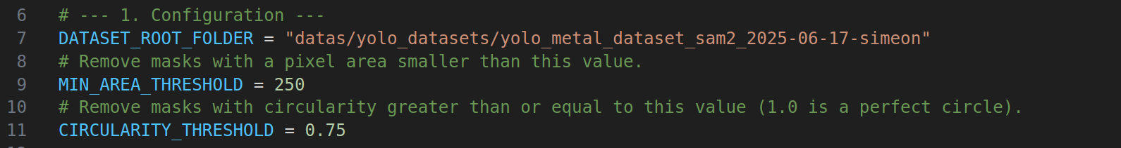

# Run the script: *python* *clean_noise_dataset.py*

The script will clean the dataset and give you some stats

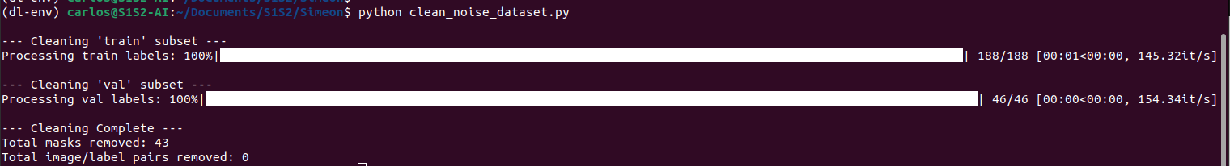

# Fine-tune Yolo Dataset

## Setup

pip install ultralytics

## Run Script

Open the script *finetune.py* and select the size of model and set the path to the dataset

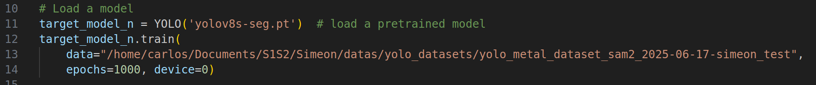

Run the script with *python finetune.py*

Wait until training ends and pick the best.pt weight from the corresponding run

# Extract Shape Features

# Open the script *extract_shape_features.py* and setup the input, outputs, checkpoints, and CFG paths

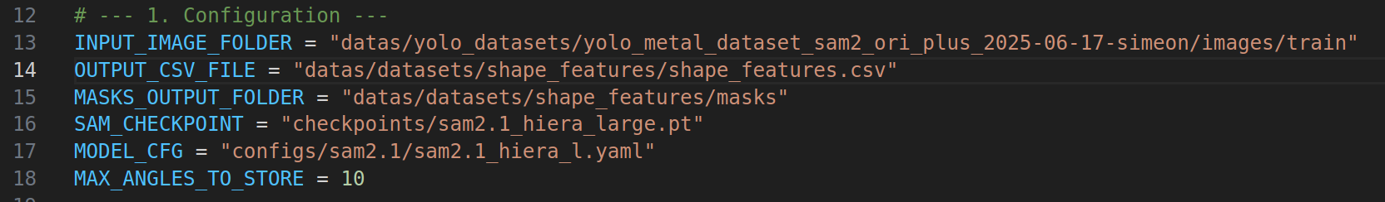

Run the script: python *extract_shape_features.py*



Enter the comma-separated list of labels



Select the index of the label to extract features for.

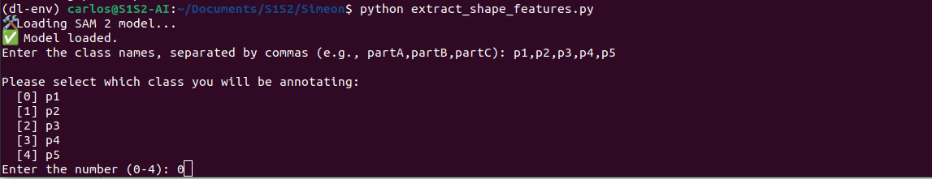

Script ready to extract features for selected label

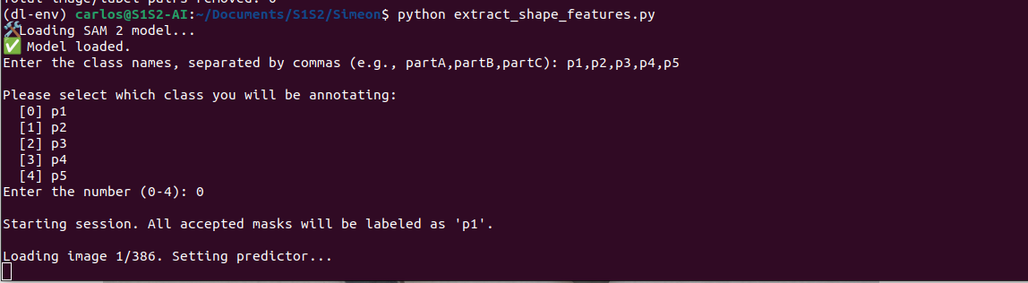

Right-click on a shape with the selected label that can clearly be picked up by the robot. Note: do not click on a part that is under other parts, as this classifier is meant to detect only the pickable shapes (the ones on top of the stack). Press *y* to extract the features for this shape or *n* to cancel.

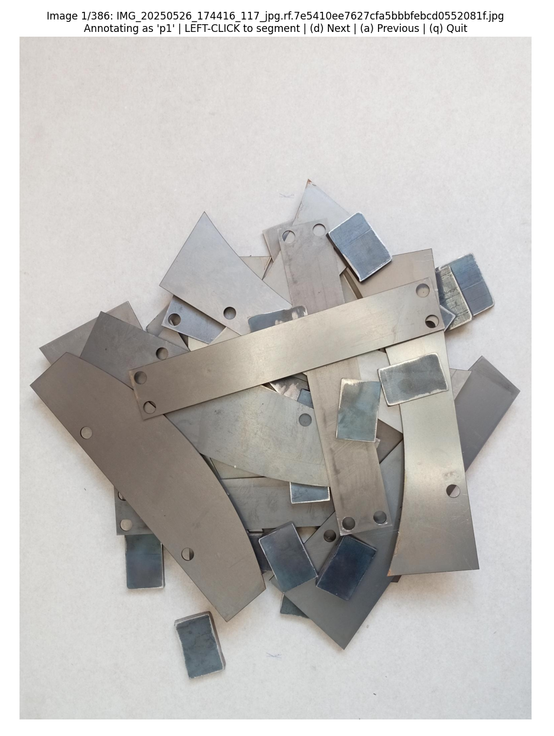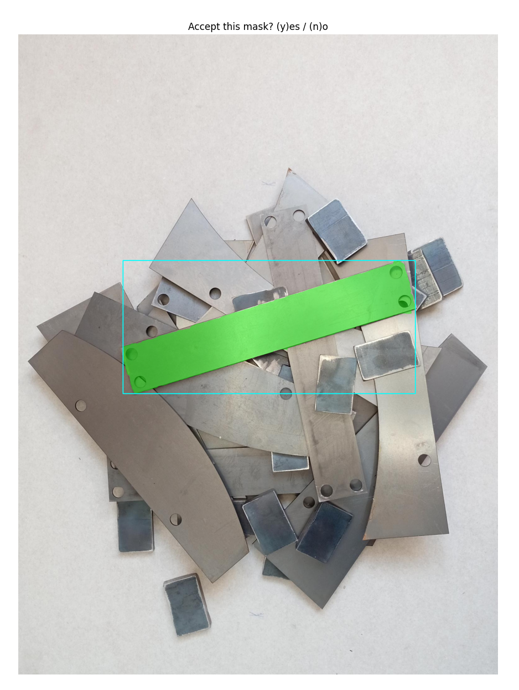

Press *d* to move to the next image or *a* to move to the previous. Navigate through the images and keep selecting parts of the selected label. When done, quit with *q*, launch again, and select a different part. Repeat until enough parts have been selected for each kind of label.

At the end, a CSV file with all the features is obtained.

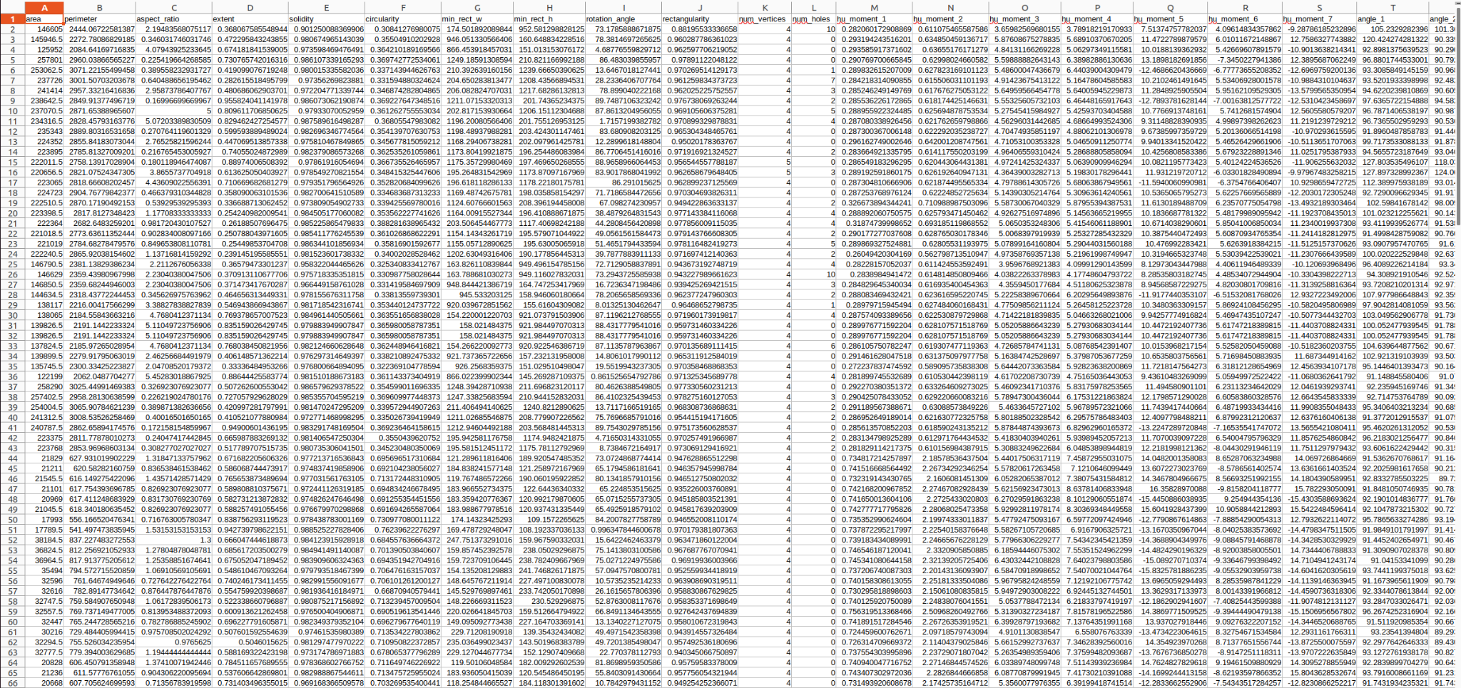

# Train Shapes Detector

## Setup

pip install seaborn

pip install scikit-learn

## Run Script

Open the *train_parts_classifier.py* script and update the path to the shape features csv file.

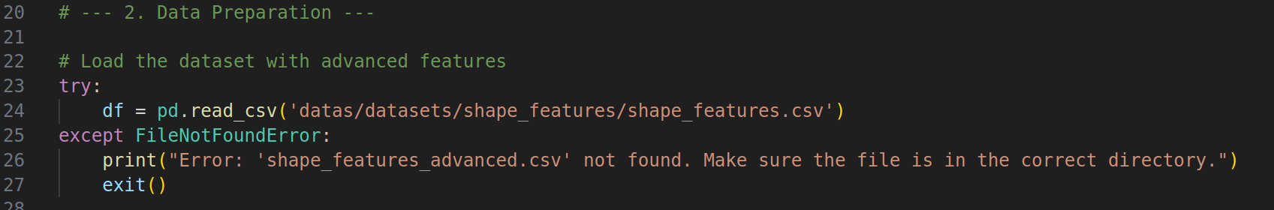

Run the *train_parts_classifier.py* script. This will train the classifier (Random Forest) and output some metrics.

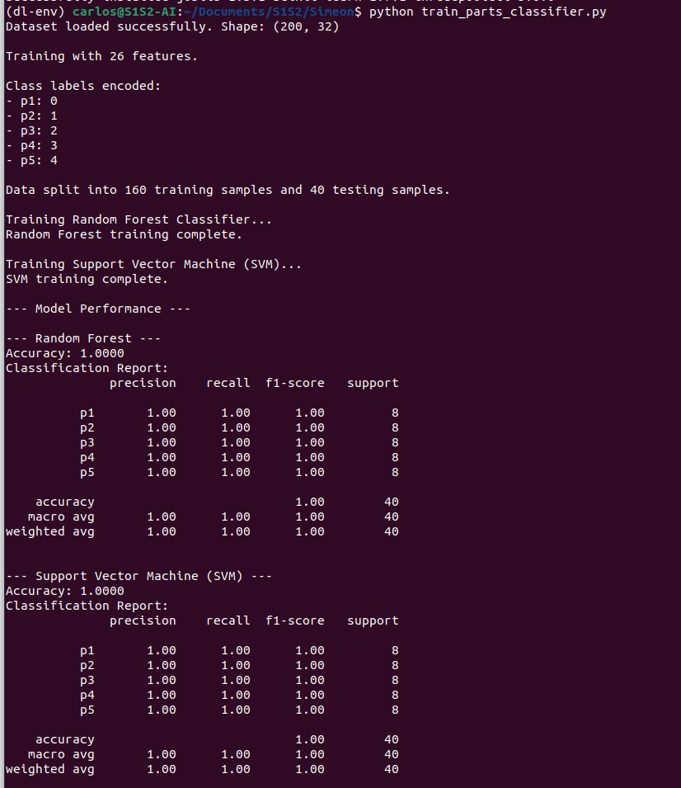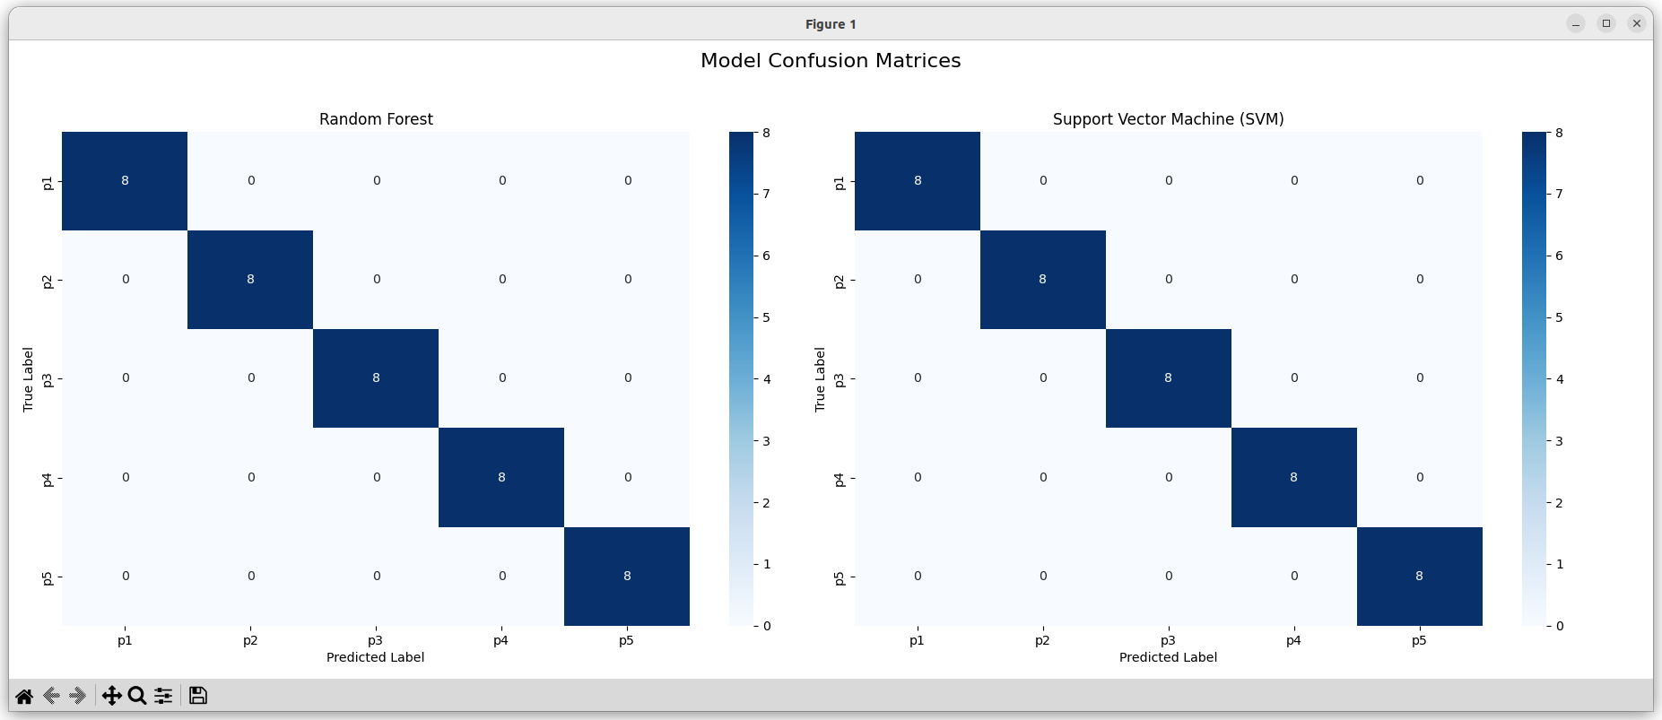

# Inference with YoloV8 + SAM2 + Random Forest

# Open the script *yolo8_to_sam2_to_part_type.py* and set the models’ paths as well as the input folder path.

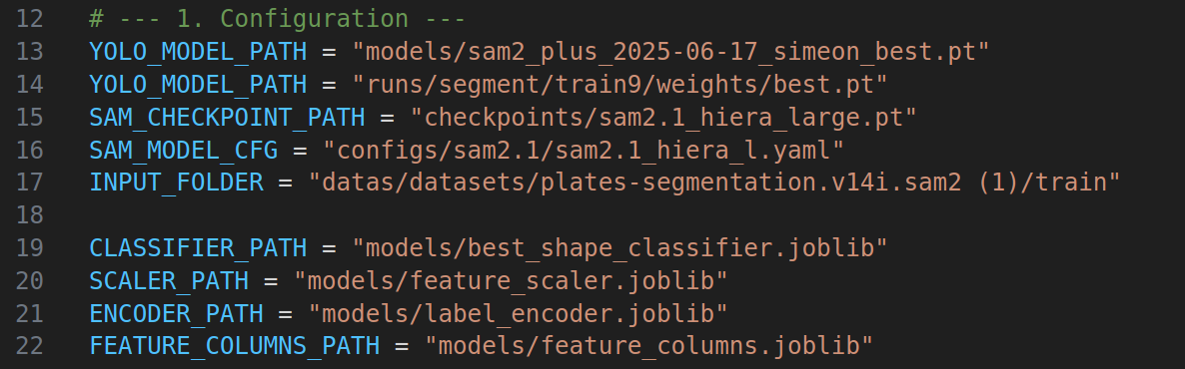

# Run the script: *python yolo8_to_sam2_to_part_type.py*

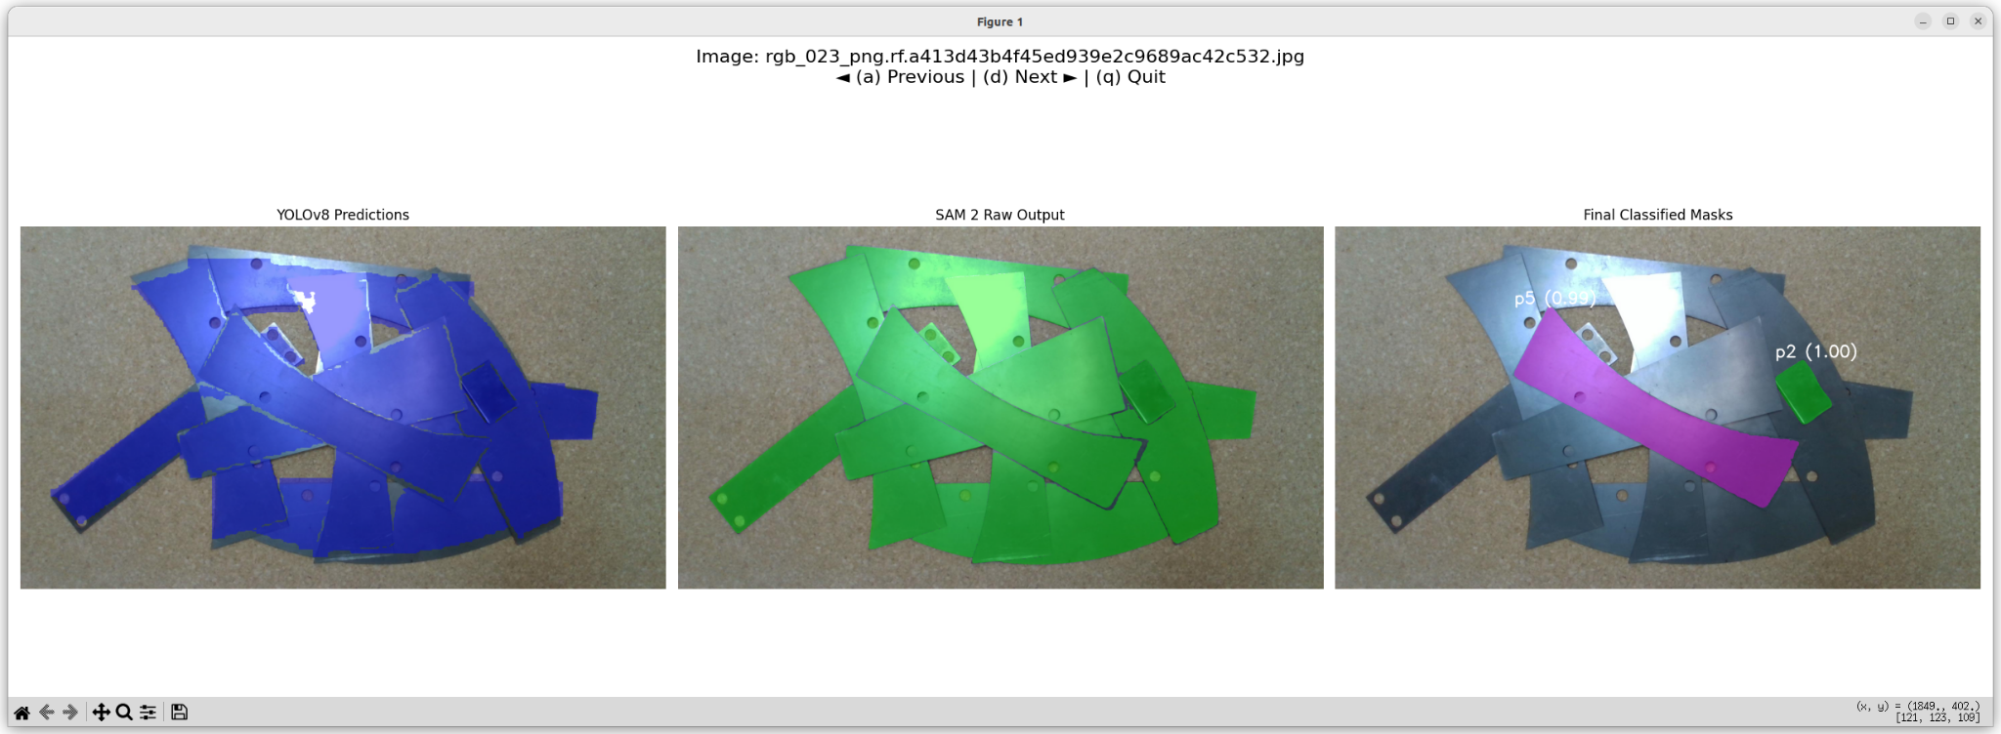

You will see 3 segmentation results. The left-most one with the blue masks is the fine-tuned Yolo output. The bounding boxes of the masks are used to prompt SAM 2 and generate more accurate masks in the middle (green). Each of the more accurate masks is further cleaned (remove small noise) and then passed to the Random Forest to detect the pickable shapes. The pickable shapes are shown on the right-most part, with the correct shape label.

# 

# 

# Other scripts that you can explore for dataset generation

# Yolo Dataset Creation with GSAM2

## Setup

pip3 install ultralytics autodistill-grounded-sam roboflow autodistill_florence_2 transformers==4.49

git clone https://github.com/autodistill/autodistill-grounded-sam-2.git

Open the script *create_dataset.py* and replace the variables to match your input data and output folder:

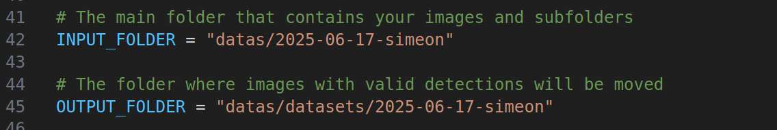

Run script: *python create_dataset.py*

# Cropping Images to focus on metal parts with GSAM2

Open the script *crop_all_with_gsam2.py* and setup your inputs and outputs

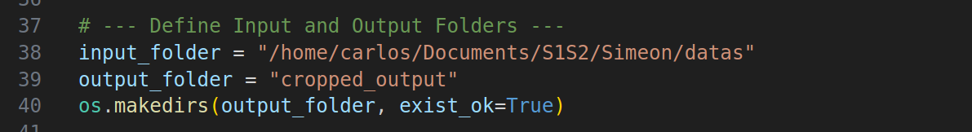

Run script: *python*  *crop_all_with_gsam2.py*